Walking and Biking
Student’s Name
Institution
Date

Walking and Biking
Introduction
Walking and biking are modes of transport that are significantly utilized by people. Health providers have encouraged people to consider engaging in walking and biking to help improve their health. When people engage in the two modes of transport, they exercise and this helps them keep fit. Research by the Centers for Disease Control and Prevention found that those who actively take part in exercises have lower risks of contracting heart diseases, reduced risk of cancer, and lowered mental health problems. The paper seeks to unravel the viewpoints and perspectives of people regarding walking and biking.
Literature Review
Walking and biking are the predominant transport modes in the world today. 20%-40% of all journeys are covered on foot or by biking (Buehler, Pucher, & Bauman, 2020). The highest percentage of walking and biking is witnessed in the Netherlands while it is lowest in Finland. Typically, most trips on foot are significantly undertaken in England while bicycle trips are frequently performed in Netherlands, Denmark as well as Sweden. Table 1 below shows people biking in the Netherlands.
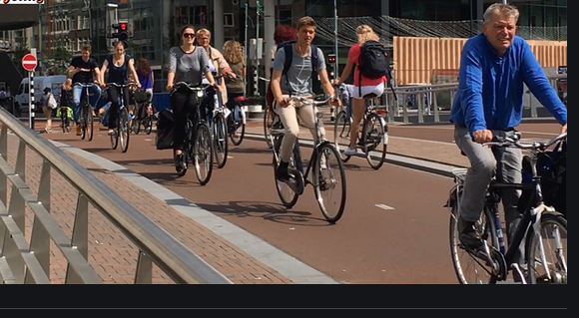
- Age groups prevalently involved in walking and biking
Various age groups are involved in walking and cycling. Age groups for which walking is specifically vital are children below the age of 12 as well as adults with age 75 and beyond. This is illustrated by data from the Netherlands where people aged 75 years and above perform one-third of the journeys on foot. Compared to the younger generation, adults aged 75 years and above use their cars slightly more often (38%) and substantially less frequently than younger adults of ages between 25 and 74 years (Liao et al., 2020). The young adults use cars more often during their trips covering more than half of the journeys. However, the bicycle is less popular among the elderly who use them less frequently – 17% on every trip. Biking is considerably utilized among the youngest age categories. Table 2 below show various age groups in the Netherlands that embrace the use of various transportation modes.
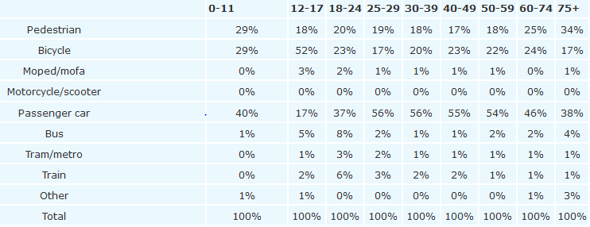
- Reasons for increased use of walking and biking
People have embraced initiatives focused on increasing walking and biking for various benefits they are likely to have on their health. Walking and biking have been touted to bolster people’s health and help in the protection of the environment. Health providers have been at the forefront of championing advocacy campaigns for biking and walking by relaying the benefits people are likely to gain. In the United States, the Alliance for Biking and Walking has been significantly involved in creating public awareness by educating the locals on the need to engage in biking and walking (Abel et al., 2019). One of the main benefits they highlight is the need to improve one’s health. This has played a crucial role in encouraging people to take part in biking and walking programs in the country.
Walking and biking are associated with myriad personal health benefits. Foremost, they help lower the risk of heart disease and stroke. Health institutions have encouraged people to actively engage in biking and walking activities. This is because when they are undertaken, the participants exercise their bodies. Hence people get to burn excess calories in the body and remain fit. Heart diseases are usually associated with high amounts of calories or cholesterols in the body (Sadik-Khan, & Solomonow, 2017). As a result, exercising is vital in ensuring that people get rid of excess fats and cholesterols that may make them vulnerable to potentially life-threatening diseases.
Colley (2018) assign that people who often engage in biking and walking are less likely to die early compared to those who do not ride. Studies show that spending one hour a day on a bike can lower one’s risk of death by 18%. This has convinced many individuals to actively take part in bicycling and walking. In America, 8.3% of deaths have been attributed to insufficient levels of physical activity (Buehler, Pucher, & Bauman, 2020). Thus residents of the country have become compelled to participate in walking and biking as frequently as possible. Also, advocacy campaigns have provided people with the necessary awareness of the benefits of walking and biking. For example, many people have embraced community-wide walking as encouraged by America Walks. Increased advocacy campaigns have inspired many individuals ranging from children, youths to the elderly to be involved in biking and walking activities more frequently. Research done by the Mayo Clinic found that walking has the potential of reducing the risk of death by virtually 39%.
Sadik-Khan, & Solomono (2017) reiterate that biking and walking can reduce the risk of cancer in people. According to a 2012 Chinese study, cycling is positively associated with reduced reports of colon cancer. Cyclists involved in the study attained “45% fewer incidences of cancer” than those who did not engage in bicycling. The study has compelled many people to engage in bicycling during leisure time in a bid to bolster their health.
Torres et al. (2021) posit that biking and walking are exceptionally useful for the mind. Various studies have found that people who choose to walk or bike more often are less vulnerable to mental health problems than those who do not. People who actively participate in walking or biking activities attain exercise that increases blood flow and releases endorphins reducing their overall stress. With many people, yearning to live happy lives characterized by minimal mental health issues such as depression and anxiety, walking and biking trips have significantly increased.
Shaaban & Abdur-Rouf (2020) postulate that walking and biking are essential in fighting the diabetes epidemic. In the United States, type II Diabetes is vastly problematic. The disease is attributed to a perfect storm – lack of exercise as well as poor dietary choices. Currently, many people have embraced the ditching of their cars to bike or walk to their workplaces to help reduce the risk of contracting the disease. Tellingly, biking and walking have exceptional contribution towards improving healthiness. From one of the European studies, it was found that people who engage in biking for approximately 30 minutes daily are 40% less vulnerable to contract type II diabetes. Table 3 below shows the health benefits of biking.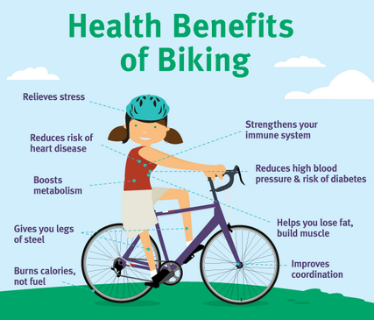
Bopp et al. (2021) demarcate that biking and walking help reduce traffic. The road across the country will become less congested as more people choose to bike and walk. In the Netherlands, roads are less congested since many people have resorted to increased biking and walking. An example is Amsterdam Highway that reported fewer congestion levels. Besides, a Canadian study delineates that countries that have invested in “active transportation” report substantial decreases in traffic and congestion (Lorenzo et al., 2020). Reduced traffic has several benefits such as more dependable travel times, reduced costs of transportation, reduced delays resulting from traffic accidents, and increased access to various facilities and services within the city. Locals of various countries such as the US, Sweden, Netherlands, England, and many more have joined efforts to engage in biking and walking transport modes to ensure that there is reduced traffic.
Den Hoed & Jarvis (2021) highlight that walking and biking transport modes have fantastic environmental benefits. For instance, when people ditch their cars to walk and bike, they help reduce the emission of greenhouse gases into the atmosphere. Transportation is regarded as the primary contributor of greenhouse gases in the world today. According to the United Nations Framework Convention on Climate Change (UNFCCC), fuel-powered vehicles are accountable for 28.5% of every greenhouse emission in America (Torres et al., 2021). The greenhouse gases have adverse effects on the environment as they result in heightened temperatures that lead to various weather extremes such as severe droughts, hurricanes, cyclones, and flooding. Also, world fires are experiencing in America, Australia, and African countries. Thus resorting to biking and walking is regarded to provide a solution to forestalling environmental problems. Table 4 below shows the environmental benefits of biking and walking as indicated in Bengaluru, India.
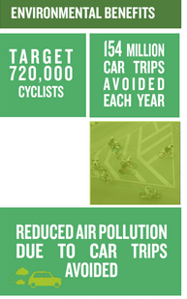
Problems associated with walking and biking
Walking and biking have several personal health benefits for people who actively engage in them. Some negative effects of biking include numbness, pain as well as erectile dysfunction (Liao et al., 2020). During cycling, male cyclists may significantly place their weights on their perineum, injuring the arteries and nerves. In the long-term, they may have long-term health problems in their reproductive organs. Furthermore, walking has been linked with various problems like foot issues – corns, calluses, and sores – arthritis of the feet and knees as well as abnormal muscle or bone development. The use of vehicles as modes of transport is still highly revered among people due to the comfort they have. Also, they offer quick delivery to the intended places. It is due to these reasons why the use of vehicles is still embraced.
Limitations of the research
i. Sample size
The sample size which was used in the research was too small hence the statistical tests which were performed were not capable of identifying significant relationships with the data set. The acquired information from the data collected was limited. By basing the collection of information through gathering a larger sample size, it would have ensured more accurate results. The findings would have been more reliable and accurate as compared to the case when a smaller sample size was used. This research employed the use of a smaller sample size which limited the amount of data collected for analysis.
ii. Scope of discussions
Tellingly, holding competent research requires one to be knowledgeable of diverse scholarly materials like the requisite academic papers to use. I am not an expert in holding research because it is not my specialty. Hence I found it challenging to comprehensively gather the literacy work of scholars. Therefore, this limited my coverage of the research work concerning people’s perspectives of walking and biking unlike in the case of experienced scholars who have enough know-how on how to collect information (Brew-Sam, 2020). I do not have many years of conducting research which may compromise the scope as well as the depth of my discussions. The works of knowledgeable scholars are standard and accurate as the information they present has been sufficiently verified and scrutinized. Their works are well-informed and conceptualized. Before I embarked on performing this research, I had difficulty in accessing the relevant digital library which would help me in finding vivid information concerning the topic. Obtaining the precise reading materials concerning perspectives of people regarding biking and walking proved to be a challenge. Even with the advancement of technology which has enhanced the research, there are still inevitable challenges of finding accurate reading materials. Despite the fact it took me long to find the relevant sources of research, I eventually settled on some online materials which enhanced my work by performing elaborate research.
iii. Time consumption
The methods used to collect data for this research were time-consuming. For example, to find authority from the various governments to access portals where perspectives and views of people regarding walking and biking were hectic. There were a lot of procedures involved to finally be permitted to gain access (Stroila, 2020). Additionally, I had limited access to the relevant personnel and departments which was a bottleneck to my research. Getting to hold talks with experienced scholars is important in that they give accurate information about a particular issue under study. Reaching out to technical experts took me a considerable amount of time to be achieved. Often, they cite a commitment to their scholarly work in investigating pertinent issues of their researches to be the reason for their inaccessibility. Thus it hampered my itinerary as far as my goal to comprehensively accomplish the research is concerned.
Conclusion
Biking and walking are popular forms of exercise and recreation in the modern world. However, they are not extensively used as purposeful modes of transportation. This is depicted in every age group from children to adults. Children and young adults comprise the highest percentage involved in biking compared to those aged over 75 years who prefer walking on trips. Conversely, health providers and advocacy groups have encouraged people to consider walking and biking to attain various health benefits. They include lower risks of contracting heart diseases, reduced risk of cancer, and reduced mental health problems. From the insightful accounts provided by every scholar in the study, it prudent for people to actively take part in walking and biking. Advocacy campaigns should be increased to help people understand the benefits associated with physical activity.

References
Abel, S., Hanzlik, M., Kraft, K., Simon, H., Isidro, C., & Mennesson, M. (2019). Walking and Biking Perspectives on Active and Sustainable Transportation: National Complete Streets Coalition, Safe Routes to School, and America Walks. Institute of Transportation Engineers. ITE Journal, 89(5), 29-34.
Bopp, M., Wilson, O., Elliott, L., Papalia, Z., & Duffey, M. (2021). Association between active transport habits and physical activity levels in a diverse sample of college students in the United States. Journal of Public Health, 1-5.
Brew-Sam, N. (2020). Summarizing Research Limitations. In App Use and Patient Empowerment in Diabetes Self-Management (pp. 273-274). Springer, Wiesbaden.
Buehler, R., Pucher, J., & Bauman, A. (2020). Physical activity from walking and cycling for daily travel in the United States, 2001–2017: Demographic, socioeconomic, and geographic variation. Journal of Transport & Health, 16, 100811.
Colley, R. C., Butler, G., Garriguet, D., Prince, S. A., & Roberts, K. C. (2018). Comparison of self-reported and accelerometer-measured physical activity in Canadian adults. Health Rep, 29(12), 3-15.
Den Hoed, W., & Jarvis, H. (2021). Normalising cycling mobilities: an age-friendly approach to cycling in the Netherlands. Applied Mobilities, 1-21.
Liao, B., EW van den Berg, P., van Wesemael, P. J., & A Arentze, T. (2020). How does walkability change behavior? A comparison between different age groups in the Netherlands. International journal of environmental research and public health, 17(2), 540.
Lorenzo, E., Szeszulski, J., Todd, M., Mama, S. K., & Lee, R. E. (2020). Health is power: active transportation, physical activity, and cardiometabolic health among ethnic minority women. Journal of physical activity and health, 17(3), 323-330.
Sadik-Khan, J., & Solomonow, S. (2017). Improving public health by making cities friendly to walking and biking: safer, more active transportation starts with the street. JAMA internal medicine, 177(5), 613-614.
Shaaban, K., & Abdur-Rouf, K. (2020). Assessing Walking and Cycling around Schools. Sustainability, 12(24), 10607.
Stroila, I. (2020). Limitations and Future Research. In Drivers and Barriers of Women Entrepreneurs (pp. 75-76). Springer Spectrum, Wiesbaden.
Torres, E. R., Bendlin, B. B., Kassahun-Yimer, W., Magnotta, V. A., & Paradiso, S. (2021). Transportation physical activity earlier in life and areas of the brain related to dementia later in life. Journal of Transport & Health, 20, 100992.

